Generate QR Code with PowerShell in Windows 10

PowerShell is an advanced form of command prompt. It is extended with a huge set of ready-to-use cmdlets and comes with the ability to use .NET framework/C# in various scenarios. PowerShell allows creating QR codes to share information between your devices and with other users.

**ADVERTISMENT**

There are plenty of methods and apps you can use to generate a QR code. However, PowerShell is a built-in solution, since it is bundled with the OS. See [All ways to open PowerShell in Windows 10](https://winaero.com/blog/all-ways-to-open-powershell-in-windows-10/).

There is a special module, [QRCodeGenerator](https://www.powershellgallery.com/packages/QRCodeGenerator/1.1" \t "_blank), which can be used to generate QR codes. It supports the following object types.

* Contact cards (vCard)
* WiFi network data
* Geolocation

First of all, you need to add the mentioned module to your PowerShell setup. Do it as follows.

**Install the QRCodeGenerator module**

1. Open a new [PowerShell console as Administrator](https://winaero.com/blog/all-ways-to-open-powershell-in-windows-10/#elevated).
2. Type or copy-paste the following command: Install-Module -Name QRCodeGenerator. Tip: See [Fix Install-Module is missing in PowerShell.](https://winaero.com/blog/fix-install-module-missing-powershell/)
3. Confirm the NuGet provider update if prompted (type "y").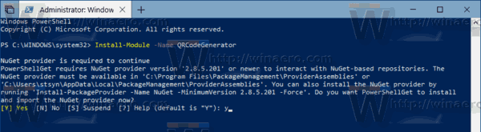
4. Next, confirm the installation from the 'PSGallery' repo. Again, enter "y".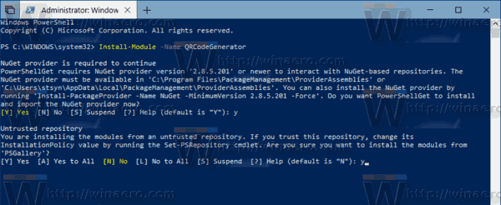

You are done. Now you can use the module in your scenarios. Here is how.

**To generate a QR Code with PowerShell in Windows 10**, do the following.

1. Open a new [PowerShell console](https://winaero.com/blog/all-ways-to-open-powershell-in-windows-10/#elevated).
2. [Change PowerShell Execution Policy](https://winaero.com/blog/change-powershell-execution-policy-windows-10/) to 'Unrestricted'. In short, run the command Set-ExecutionPolicy Unrestricted -Scope Process.
3. Confirm the command.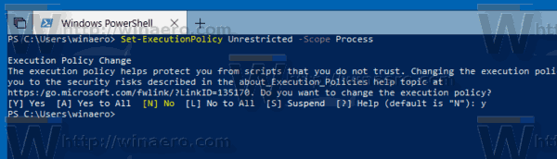
4. Load the module with the next command: Import-Module QRCodeGenerator.
5. Now you can use it to generate a QR code and save it as a PNG image. For example, you can generate a QR code for your wireless network using the following syntax:  
   New-QRCodeWifiAccess -SSID $wifi -Password $pwd -OutPath $path

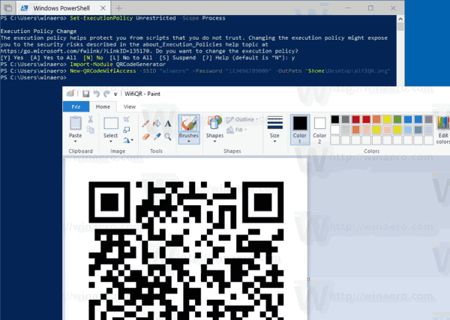

You are done. Other usage examples:

* Generate a vCard QR code: New-QRCodeVCard -FirstName $first -LastName $last -Company $company -Email$email -OutPath $path
* Generate a Geolocation QR code: New-QRCodeGeolocation -Address $address -OutPath